Name: ____________________ EXERCISE – Grade 1

Class: _______

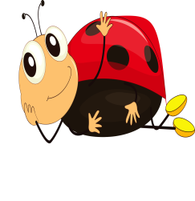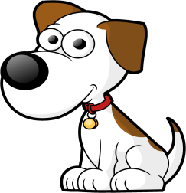 **I. Look and circle.**

**1. 2. 3.**

h a d d e b f c i

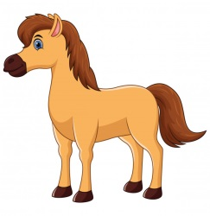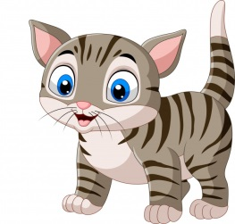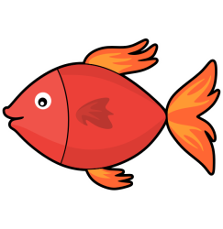**4. 5. 6.**

c g a g f c g h b

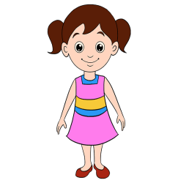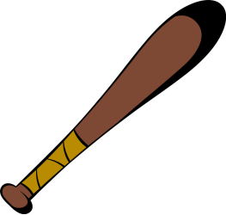 **7. 8. 9.**

c g b c e b g f e

**II. Look and read. Put a tick (✓) or a cross (🗶) in the box.**

|  |  |
| --- | --- |
| This is a notebook.  ✓ | **2.**  This is a chair. |
| **3.**  This is a pen. | **4.**  This is a crayon. |

**III. Look at the picture. Put a tick 🗹 in the correct box.**

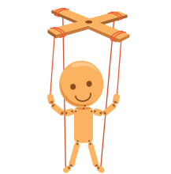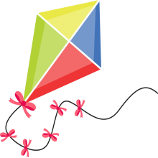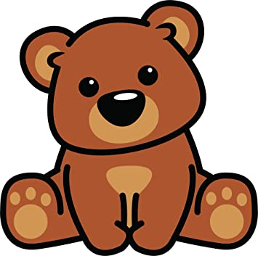**1.** Is it a teddy bear? **2.** Is it a plane? **3.** Is it a balloon?

Yes, it is. □ Yes, it is. □ Yes, it is. □

No, it isn’t. □ No, it isn’t. □ No, it isn’t. □

**IV. Look at the picture and choose the correct letter. Then write.**

|  |
| --- |
| **t b p p r** |

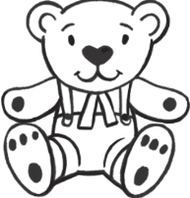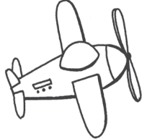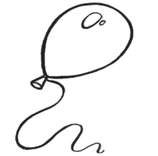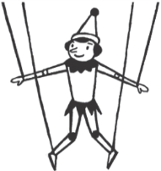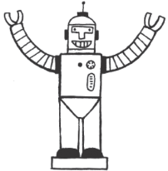

1. **2. 3. 4. 5.**

_**p** uppet __obot __alloon __lane __eddy bear

**V. Look and write.**

**four two three one six five**

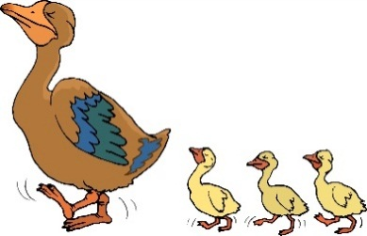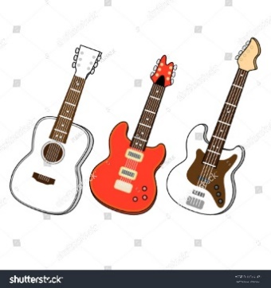

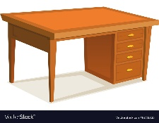

**1.** **three 2. _______ 3.___________**

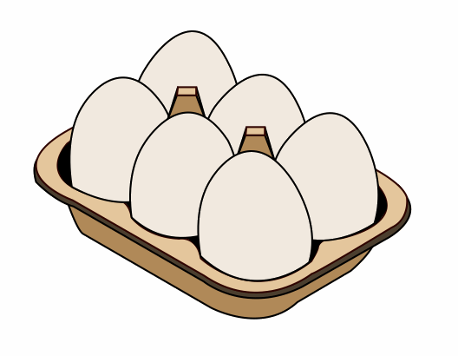

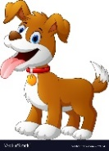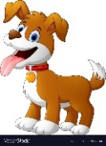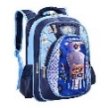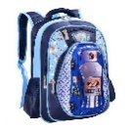

**4.**__________ **5.** _______ **6.**__________

**🕮 Good luck to you! ☺**

**ĐÁP ÁN BÀI TẬP ANH VĂN - LỚP 1**

**I. Look and circle.**

**1.** a **2.** d **3.** i **4.** c **5.** f

**6.** h **7.** b **8.** e **9.** g

**II. Look and read. Put a tick (✓) or a cross (🗶) in the box**.

1. ✓
2. 🗶
3. 🗶
4. ✓

**III. Look at the picture. Put a tick 🗹 in the correct box.**

**1.** Yes, it is. **2.** No, it isn’t. **3.** No, it isn’t.

**IV. Look at the picture and choose the correct letter. Then write.**

**1.** p **2.** r **3.** b **4.** p **5.** t

**V. Look and write.**

**1.** three

**2.** one

**3.** four

**4.** six

**5.** two

**6.** five

**🕮 The end ☺**

Name: ____________________ EXERCISE – Grade 1

Class: _______

**I. Circle the odd-one-out and match.**

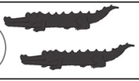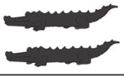

**1.**

tiger

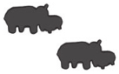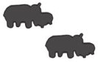

1. crocodile



1. hippo



1. bear
2. bird

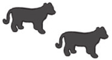

**II. Read and match.**



1. What are they? They’re bears.



1. What are they? They’re tigers.



1. What are they? They’re hippos.

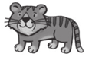

1. What are they? They’re birds.

**III. Count, match, and write. 9 10**

1. 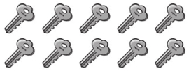nine
2. 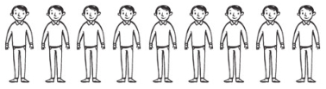 ten

**IV. Look and color.**

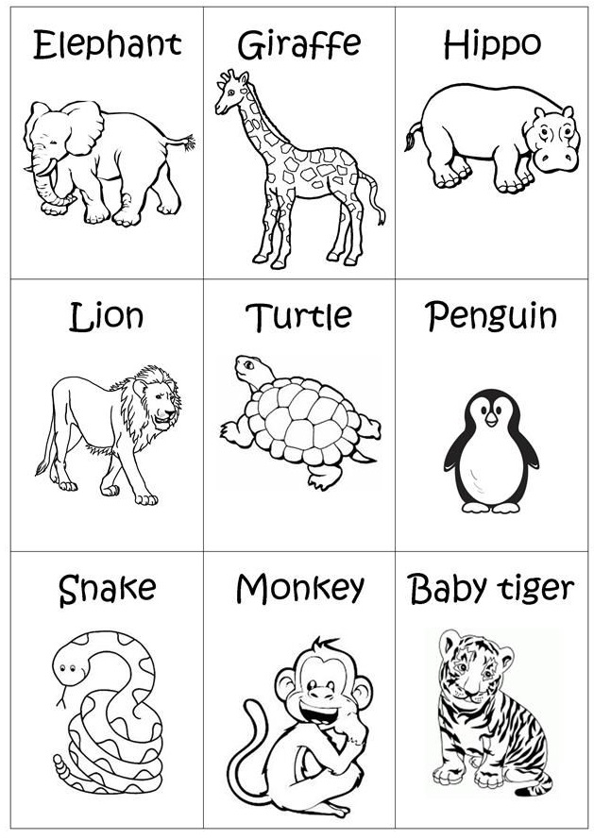

**3**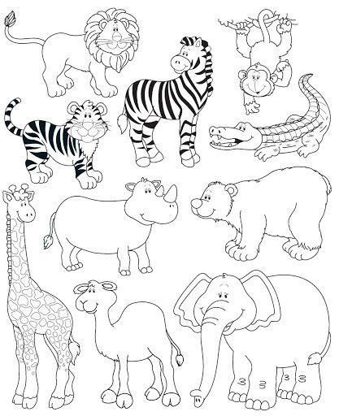

**2**

**1**

**6**

**5**

**4**

**9**

**8**

**7**

**1.** gray **2.** yellow **3.** gray **4.** orange **5.** red

**6.** white **7.** green **8.** brown **9.** orange

**🕮 Good luck to you! ☺**

**ĐÁP ÁN BÀI TẬP ANH VĂN - LỚP 1**

**I. Circle the odd-one-out and match.**

1. bird
2. bear
3. crocodile
4. tiger
5. hippo

**II. Read and match.**

1. They’re hippos.
2. They’re bears.
3. They’re birds.
4. They’re tigers.

**III. Count, match, and write.**

1. 10
2. 9

**IV. Look and color.**

**1.** Màu xám **2.** Màu vàng **3.** Màu xám

**4.** Màu cam **5.** Màu đỏ **6.** Màu trắng

**7.** Màu xanh lá cây **8.** Màu nâu **9.** Màu cam

**🕮 The end ☺**